INTERFERONS AND INTERFERON INDUCERS
Definition
Interferons are a group of signaling proteins produced and released by host cells in response to the presence of pathogens, such as viruses, or other foreign substances that may harm the body. It is part of the body’s innate immune response and the first line of defense against virus and other infections.
IFNs belong to the large class of proteins known as cytokines, molecules used for communication between cells to trigger the protective defenses of the immune system that help eradicate pathogens. Interferon mediates both inter or intra-cellular defense, where the one cell passes a signal to the other cell via TLR (toll-like receptors). TLR receives a signal generated by the host cell and gives the information to the immunogenic cells.
IFNs are currently used therapeutically, with the most noteworthy example being the treatment of hepatitis C virus (HCV) infection, and they are also used against various other disorders, including numerous malignancies and multiple sclerosis

Historical background
Interferon was first discovered by two scientists, Isaac and Lindenmann in 1957, while experimenting on the chick chorioallantoic membrane fragments with the live influenza virus. On experiment, Isaac and Lindenmann found that the interaction of the host cell and virus produced some diffusible antiviral substance.
Later, the antiviral substance was named “Interferons” as they interfere with the replication of the viral genome and makes the cell impervious against the viral infection. Interferons also deal with the bacterial and parasitic attack, by inhibiting cell division and promoting cell differentiation. Interferons are then, described as proteins that are produced and released by host cells in response to viral infections or other forms of cellular stress.
The first interferon to be identified was alpha interferon, which was isolated and characterized in the late 1950s. Beta interferon was identified a few years later, and gamma interferon was discovered in the 1970s.
In the 1980s, researchers began to investigate the potential use of interferons as therapeutic agents. Alpha interferon was approved by the US Food and Drug Administration (FDA) for the treatment of hairy cell leukemia in 1986, and since then, it has been approved for the treatment of different viral infections and certain types of cancer. In 1993, Beta interferon was approved by the FDA for the treatment of multiple sclerosis, and gamma interferon was approved for the treatment of chronic granulomatous disease, a rare genetic disorder.
Types of interferons:
Interferons are broadly classified into three main classes based on the type of producing cells and their functions.
- Type 1 Interferons (IFN-α and IFN-β).
- Type 11Interferon (IFN-γ)
- Type III Interferon (IFN-λ)
Type 1 Interferons
Alfa and Beta Interferons (IFN-α/β) are identical in structure and function. They are produced in response to viral infections and are part of non-specific (innate) immunity. They have antiviral and antitumor properties and are used to treat a variety of viral infections such as hepatitis B and C infections and certain types of cancer. IFN- β are used to treat various kinds of multiple sclerosis (MS), an autoimmune inflammatory illness. The medication can reduce inflammation in your spinal cord and brain to prevent nerve damage.
IFN- α (aka leucocyte interferons) is secreted by virus infected leukocytes (WBC) such as neutrophils, eosinophils, basophils, monocytes, macrophages and lymphocytes (B and T cells). IFN- β (fibroblast interferon) is secreted by fibroblasts.
All type 1 interferons bind to a specific cell surface receptor known as interferon-α/β receptor which is made of 2 chains: interferon alpha receptor 1 and 2 (IFNAR1 and IFNAR2). The binding of interferons to the receptor follows a JAK-STAT signaling pathway.
IFN-α can be used in the treatment of various conditions, including cancers and infections such as: chronic hepatitis B and C, hairy cell leukemia (blood cell cancer), kaposi sarcoma (AIDS-related tumor), non-Hodgkin lymphoma, renal cell carcinoma (a type of kidney cancer), malignant melanoma and genital warts.

Functions of type I interferons
- Interfere with viral replication in uninfected cells.
- Alert immune cells such as NK cells, that infection has occur.
- Involved in innate (non-specific) immunity
Type II interferons: IFN-γ
IFN-γ forms part of the adaptive immunity and are expressed later in the course of infection. They are produced by T lymphocytes (T cells and B cells) and NK cell. They are known to stimulate the activity of macrophages and thus, known as macrophage activation factor. IFN-γ are used in the treatment of chronic granulomatous disease, a disease that affects the immune system. They also use it to treat severe malignant osteopetrosis, which is a disease that affects your bones.
Type III interferons: IFN-λ
Interferon lambda (IFN-λ) was discovered more recently, and is still under investigation. These are produced by the epithelial cells.
Although interferon lambda is considered to have critical roles in viral infections, cancer and autoimmune diseases, it’s only been shown experimentally to be useful for the treatment of chronic hepatitis C viral infection. It isn’t currently approved or authorized by the FDA for any clinical use.
Mechanism of antiviral action of interferons
When a virus infects a cell, the binding sends a signal to the nucleus to activate interferon stimulating genes (ISGs) which stimulates the production of molecule called interferons (IFNs). These IFN are released by the infected host cell to the surrounding environments made u of other immune cells. They bind to the receptors on the membrane surfaces nearby cells and signal the nucleus through a pathway known as the JAK-STAT pathway, to transcribe antiviral genes which leads to the synthesis of proteins called antiviral proteins such as PKR (protein kinase R), 2,5- oligoadenylate synthetase (OAS), Mx proteins, ISG15s (IFN-stimulated protein of 15 kDa), IRFs, ADAR1 (adenosine deaminase, RNA-specific 1), which stimulate antiviral, antiproliferative and immunomodulatory responses.

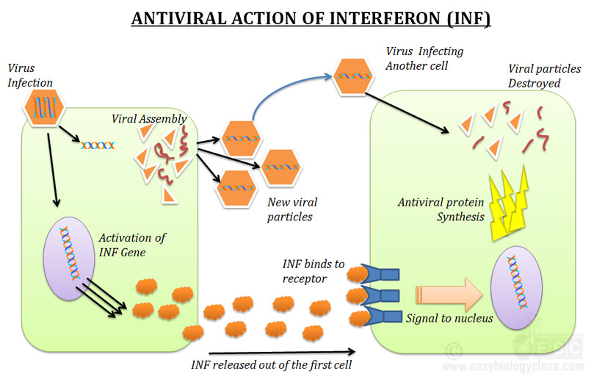

Pathway of interferon mediated signaling
The mechanism of interferon gene activation in uninfected cells follow a signaling pathway (eg. JAK-STAT pathway), transcription actors (eg. IRFs, NF-kB) or pattern recognition receptors (PRRs)
The JAK-STAT signaling pathway is a chain of interactions between proteins in a cell, and is involved in processes such as immunity, cell division, cell death, and tumor formation. The pathway communicates information from chemical signals outside of a cell to the cell nucleus, resulting in the activation of genes through the process of transcription. There are three key parts of JAK-STAT signaling: Janus kinases (JAKs), signal transducer and activator of transcription proteins (STATs), and receptors (which bind the chemical signals). Disrupted JAK-STAT signaling may lead to a variety of diseases, such as skin conditions, cancers, and disorders affecting the immune system.
On the surfaces of uninfected cells are IFN receptors which are normally tyrosine kinase which associate with JAK (Janus kinase). Type 1 interferons (IFN-α and IFN-β) bind to a specific cell surface receptor complex known as the IFN-α/β receptor (IFNAR) that consists of IFNAR1 and IFNAR2 chains. Type II IFNγ binds a tetramer consisting of two IFNGR2 (IFNγ receptor 2) chains and two IFNGR1 chains while type III IFNλ binds the interleukin-10 receptor 2 (IL-10R2), also known as IL-10Rβ which associates with IFNLR1 (IFNλ receptor 1), also known as IL-28Rα. Following binding by type I IFNs, signal transduction is initiated by pre-associated tyrosine kinases (JAK1 and TYK2 (tyrosine kinase 2)), which phosphorylate IFNAR1 and leads to the recruitment and phosphorylation of the signal transducers and activators of transcription (STATs). STAT heterodimers associate with IFN-regulatory factor 9 (IRF9) to form IFN-stimulated gene factor 3 (ISGF3), or STAT homodimers to form the IFN-γ activation factor (GAF). These complexes translocate to the nucleus to induce IFN-stimulated genes from IFN-stimulated response elements (ISREs) or GAS promoter elements, for type I and type III, or type II IFN responses, respectively. The production of ISREs result in transcription of ISGIs (IFN-stimulated protein of 15 kDa), Mx (myxovirus resistance), OAS (2',5'-oligoadenylate synthetase) and PKR (protein kinase R) proteins which will help the cells come back against viral infections and induce immunomodulatory responses while the GAS promoter elements in type II IFN responses results in transcription of GAS proteins has antimycobacterial immunity.
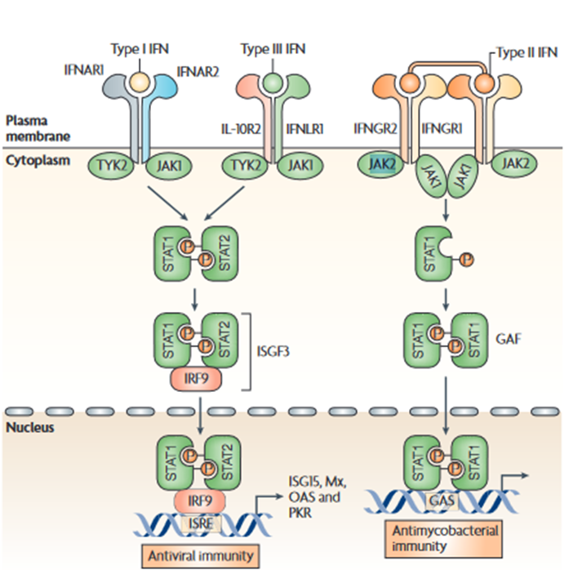

Mechanisms of actions of antiviral proteins (ISG15, Mx1, RNaseL and PKR) in host immune response
There are three pathways through which antiviral proteins stimulate antiviral defense mechanisms. These mechanisms can work together or individually to protect an immune cell from viral infections. They include:
- Inhibition of translation
- mRNA degradation and
- inhibition of viral assembly
Inhibition of translation of viral proteins
When IFN binds to the interferon receptors (type 1 IFN receptors (IFNAR1, IFNAR2) on the cell surface and signaling occurs, it can produce protein kinase R (PKR) (a defense molecule) which binds to viral dsDNA/RNA and stops translation of RNA. PKR can also phosphorylate initiation factor 2 alpha (IF2α), leading to inhibition of viral translation.

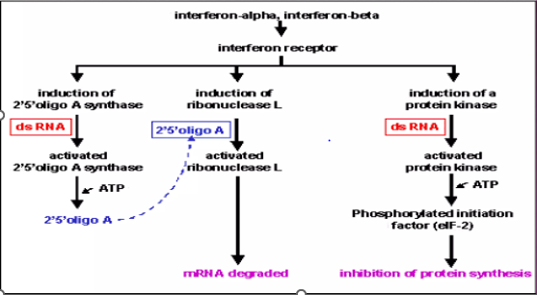
Mechanisms of actions of antiviral proteins
Degradation of viral mRNA
2′,5′-oligoadenylate synthetase (OAS) and ribonuclease L (RNaseL) proteins accumulates in the cell cytoplasm as an inactive monomer. Following activation by viral double-stranded RNA (dsRNA), the enzyme, OAS oligomerizes to form a tetramer that synthesizes 2′,5′oligoadenylates that, in turn, activate the expressed inactive ribonuclease L (RNaseL). The binding of 2′,5′-oligoadenylates to RNaseL triggers the dimerization of RNase enzyme monomers, through their kinase-like domains, and this then enables RNAseL to degrade cellular (and viral) RNAs, thereby preventing viral translation.
Inhibition of viral assembly
Once viral proteins are produced, they need to be assembled in manner to produce a functional virus. This process can be inhibited by MX (myxovirus-resistance) proteins. Following stimulation with type I interferons (IFNs), MXA (myxovirus-resistance A) gene expression is induced through an IFN-stimulated response element (ISRE) in the gene promoter. The MxA protein accumulates in the cytoplasm on intracellular membranes (such as the endoplasmic reticulum, ER) as oligomers formed by association between the leucine zipper (LZ) domain and central interactive domain of the protein. Following viral infection, MxA monomers are released and bind viral nucleocapsids or other viral components, to trap and then degrade them. Viruses that are susceptible to the activities of Mx proteins include orthomyxoviruses, paramyxoviruses, rhabdoviruses, togaviruses and bunyaviruses.

Biological functions of interferons:
- Antiviral effect: Interferons are used to treat a variety of viral infections, including hepatitis B and C, multiple sclerosis, and human papillomavirus infections. They are also used to prevent the recurrence of herpes simplex virus infections.
- Interferons have antiproliferative effects are used in the treatment of certain types of cancer, such as hairy cell leukemia, Kaposi sarcoma, chronic myelogenous leukemia, and melanoma. They are also used in combination with other cancer therapies, such as chemotherapy, to enhance their effectiveness.
- Interferons are used to treat some autoimmune disorders, such as multiple sclerosis and Crohn’s disease. They are also used to treat some genetic disorders, such as chronic granulomatous disease, which is a rare genetic disorder characterized by an impaired immune system.
- Interferons are used in combination with other antiretroviral drugs to treat HIV/AIDS. They are believed to enhance the effectiveness of these drugs by inhibiting the replication of HIV and boosting the immune system.
- They activate immune cells such as Natural killer (NK) cells and macrophages.
- Immunomodulatory functions: They enhance host defense by increasing recognition of infections or tumor cells by enhancing antigen presentation to T- lymphocytes.
- Induction of apoptosis in certain cells.

Clinical toxicities of interferon administration
The use of interferons in clinical practice is associated with some side effects which can be dose dependent. Appropriate timing of administration (eg. At or just before bedtime) can limit the impact of symptoms. Acute administration of IFN can result in fever, headache, nausea, vomiting, diarrhea, depression, partial alopecia and fatigue which increases with repetitive dosing. Anorexia and weight loss are commonly seen with higher-dose regimens.
Hematologic toxicities include anemia, neutropenia, and thrombocytopenia are rarely reported in low dose regimens. Organ toxicities associated with interferon treatment include skin rashes, reversible proteinuria, interstitial nephritis, and acute hepatic toxicities.

Interferon drugs available for clinical use
Interferons for clinical use include both the recombinant versions of a specific interferon serotype and purified blends of natural human interferons. Hese drugs are given intramuscularly or subcutaneously.
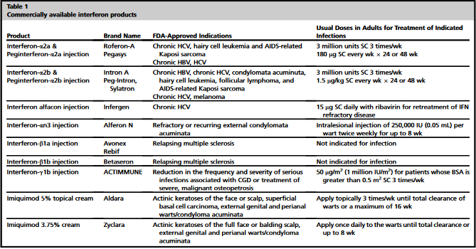
Production of Interferons
Interferons are produced by living animal cells both in vivo and in cultured cells. Interferon production starts after initiation of viral maturation and continue for about 20 to 50 hours. Production stops due to the formation of a repressor protein which is activated only when the interferon concentration in the producing cell exceeds a certain threshold concentration and are transported from the producing cell to other neighboring cells.

Commercial production of interferons
There are several methods for producing interferons commercially.
Recombinant DNA technology involves the use of genetically modified cells, such as bacteria or yeast, to produce large quantities of interferons. This method involves the insertion of a gene encoding the desired interferon into the genome of the host cells, which are then grown in large fermentation tanks under controlled conditions. The interferon is purified from the culture supernatant or cell lysate by a series of steps, including centrifugation, filtration, and chromatographic separation.
Tissue culture-based methods involve the use of cells that naturally produce interferons, such as fibroblasts or lymphocytes, to produce large quantities of interferons. These cells are cultured in bioreactors or cell culture flasks and are stimulated to produce interferons using various methods, such as chemical agents or viral infections. The interferon is purified from the culture supernatant or cell lysate using similar methods as described above.

Interferon inducers
These are agents that promote the production and release of interferons. They can also be made manually in a lab to use as treatments for various diseases. They act in a similar way to the natural interferons your body makes. The nature of this substance was identified by Merigan in 1970 as ds RNA.
Scientists created the first lab-made interferons in 1986 as a treatment for certain kinds of cancer. Since then, different types of interferons have been created to fight other illnesses and infections.

Properties of an interferon inducer
An ideal interferon inducer for use in animals and man should possess the following characteristics:
- significantly non-toxic,
- non-infective,
- Non-antigenic,
- free of teratogenic or carcinogenic potential,
- of acceptable cost,
- possess efficacy of sufficient intensity and duration.

Importance of interferon inducers in antiviral therapy
- Broad spectrum antiviral activity: they stimulate the production of interferons with broad spectrum antiviral properties ie targeting a wide range of viruses
- Immune system modulation: Interferon inducers boost innate immune response which is the body’s first line of defense against infections by activating immune cells such as macrophages and natural killer cells, thereby enhancing overall immune response.
- Reduction of viral replication: Interferon inducers stimulate the production of IFNs which inhibits viral replication within the host cell, thereby interfering with viral RNA and protein synthesis, limiting viral spread.
- Combination therapy: these inducers can be used in combination other antiviral drugs to enhance therapeutic efficacy which can result in better clinical outcomes eg. in chronic viral infections such as hepatitis B and C.
- Reduced resistance: using the body’s own immune mechanisms to combat viruses can reduce the development of resistance, a common issue with direct acting antiviral drugs.
- Potential for prophylaxis: can be used as preventive measures to boosters immune response in high-risk populations to reduce the rate of infections.
B. Natural Interferon Inducers
Viruses: both RNA and DNA viruses. Ds RNA viruses eg. Reoviruses can act as IFN inducer without replication. Ss RNA viruses –also act as inducers only after replication of their ds replicative intermediates. DNA viruses – also induce IFN presumably due to overlapping transcription of viral DNA eg. Vaccinia virus
Bacteria/bacteral products such as endotoxins (lipopolysaccharides)
Fungi with ds RNA – are good IFN inducers
Synhetic/ non microbial IFN inducers can be:
Mitogens: A mitogen is a small bioactive protein or peptide that stimulates cell division. They are responsible for the unchecked growth observed in tumor cells eg. Phytohemagglutinins, concanavalin A (Con A), synthetic lipopolysaccharides (activate B- cells), pokeweed mitogen (activate both B and T- cells).
Polysaccharides: eg. Β- glucan.
Polyanions: stable, high mol. Weight, and high density free anionic groups eg.
Polynucleotides: eg. Thermostable ds RNAs and ds DNAs such as polyadenylic- polyuridylic acids (poly A:U) and polyinosinic-polycytidylic acid (poly I:C). These are synthetic biological immune response modifiers consisting of two chain RNA polymers.ds RNA mol. They are used to stimulate viral infections through interaction with toll-like receptor 3 which is expressed at the endosomal membrane of B-cells, macrophages and dendritic cells.
Clinical applications of interferons:
Viral infections: Interferons are used to treat a variety of viral infections, including hepatitis B and C, multiple sclerosis, human papillomavirus infections, and Kaposi’s sarcoma. They are also used to prevent the recurrence of herpes simplex virus infections.
Cancer: Interferons are used to treat certain types of cancer such as hairy cell leukemia, Kaposi sarcoma, chronic myelogenous leukemia, and melanoma. They are also used in combination with other cancer therapies, such as chemotherapy, to enhance their effectiveness.
Autoimmune disorders: Interferons are used to treat some autoimmune disorders, such as multiple sclerosis and Crohn’s disease. They are also used to treat some genetic disorders, such as chronic granulomatous disease, which is a rare genetic disorder characterized by an impaired immune system.
HIV/AIDS: Interferons are used in combination with other antiretroviral drugs to treat HIV/AIDS. They are believed to enhance the effectiveness of these drugs by inhibiting the replication of HIV and boosting the immune system.

